**Dimensionality Reduction:**

* Dimensionality reduction is the process of reducing the number of input variables (features) in a dataset while retaining as much relevant information as possible.
* It is commonly used in machine learning, deep learning, and data analysis to improve model performance and visualization.

**How Dimensionality Reduction Works?**

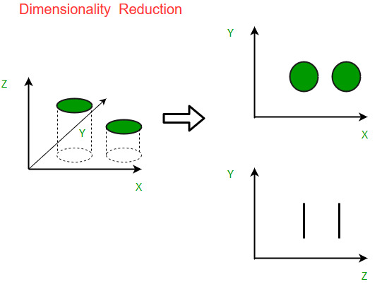

Dimensionality reduction simplifies data by removing less important dimensions while preserving valuable information. In the figure, the original data exists in 3D (X, Y, Z), but the Z-dimension adds little value. After reduction, the data is effectively represented in 2D (X-Y), retaining its structure while improving computational efficiency, visualization, and minimizing redundancy.

**Steps in Dimensionality Reduction:**

**Step 1: Data Preprocessing**

Before applying dimensionality reduction techniques, proper preprocessing is needed:

* **Handling Missing Data** – Remove or fill missing values.
* **Feature Scaling** – Standardize or normalize data to avoid dominance by large-value features.
* **Removing Correlated Features** – High correlation among features indicates redundancy, so such features can be removed.

**Step 2: Selecting a Dimensionality Reduction Technique**

1. **Feature Selection** – Selecting a subset of relevant features.
2. **Feature Extraction** – Transforming the original features into a new, lower-dimensional space.

**Feature Selection:** It**chooses** the most relevant features from the dataset without altering them. It helps remove redundant or irrelevant features, improving model efficiency.

**1. Filter Methods (Feature Selection)**

* Filter methods independently evaluate each feature’s relevance to the target variable. Features with high correlation to the target are selected, as they contribute to better predictions.
* These methods are applied during preprocessing to eliminate irrelevant or redundant features using statistical tests like correlation, chi-square, or mutual information.
* This enhances model performance and reduces computational complexity.



**2. Wrapper Methods (Feature Selection)**

* Wrapper methods iteratively select the best feature subset by training a model on different feature combinations.
* These greedy algorithms evaluate how well each subset relates to the target variable and add or remove features accordingly.
* While more accurate than filter methods, they are computationally expensive.



**3. Embedded methods**

* Embedded methods perform feature selection during the model training process.
* They combine the benefits of both filter and wrapper methods.
* Feature selection is integrated into the model training allowing the model to select the most relevant features based on the training process dynamically.

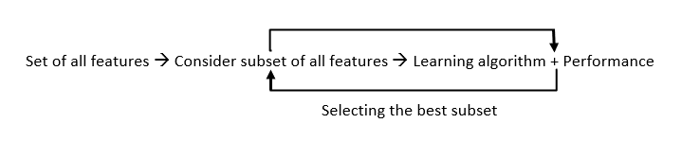

**Feature Extraction:**

* It involves creating new features by combining or transforming the original features.
* Feature extraction transforms high-dimensional data into a lower-dimensional representation while preserving essential information.

**Dimensionality Reduction Techniques**

* PCA (Principal Component Analysis): An unsupervised method that transforms high-dimensional data into a lower-dimensional space while preserving maximum variance. Useful for feature extraction and visualization.
* LDA (Linear Discriminant Analysis): A supervised technique that finds the best linear combinations of features to distinguish between classes by maximizing between-class variance and minimizing within-class variance.
* Autoencoders: Neural networks with an encoder-decoder structure that learn a compressed representation of data, useful for dimensionality reduction, anomaly detection, and generative modeling.

**Step 3: Choosing the Optimal Number of Dimensions**

* **Elbow Method (For PCA and SVD)** – Plot variance explained vs. number of components and find the "elbow" point where diminishing returns start.
* **Cross-Validation** – Use machine learning models to check performance with different feature subsets.
* **Reconstruction Error** – Measure how well-reduced data reconstructs the original data.

**Step 4: Applying the Reduced Features to a Model**

Once dimensionality is reduced:

* Train a machine learning model (e.g., SVM, Decision Trees, Neural Networks).
* Compare performance with original data.
* Use hyperparameter tuning to optimize results.

**Conclusion**

Dimensionality reduction is crucial for handling high-dimensional data efficiently. The choice of technique depends on the dataset and task requirements. PCA is useful for general reduction, LDA for classification, and t-SNE for visualization. Proper application of dimensionality reduction improves model accuracy, speeds up computation, and aids interpretability.

**Advantages:**

1. **Easier to Understand**: Fewer variables mean less complexity, making the data easier to visualize.
2. **Faster Processing**: With less data, computers can process it more quickly.
3. **Better Models**: Reducing noise helps improve the performance of machine learning models.
4. **Saves Space**: Smaller data size means less storage needed.

**Disadvantages:**

1. **Information Loss**: Important details might be lost during the reduction.
2. **Tricky Process**: Choosing the right method and parameters can be complex.
3. **Hard to Explain**: The new simplified data might not be as easy to interpret.
4. **Overfitting Risk**: If done incorrectly, models might work well on training data but poorly on new data.

**Applications:**

1. **Making Graphs**: Easier to visualize data.
2. **Smaller Images**: Compress images without losing too much detail.
3. **Cleaner Data**: Remove unnecessary parts of the data.
4. **Finance**: Simplify financial data to find trends.
5. **Biology**: Understand genetic data better.
6. **Text Analysis**: Analyze text for sentiment or topics.
7. **Recommendations**: Improve recommendation systems.